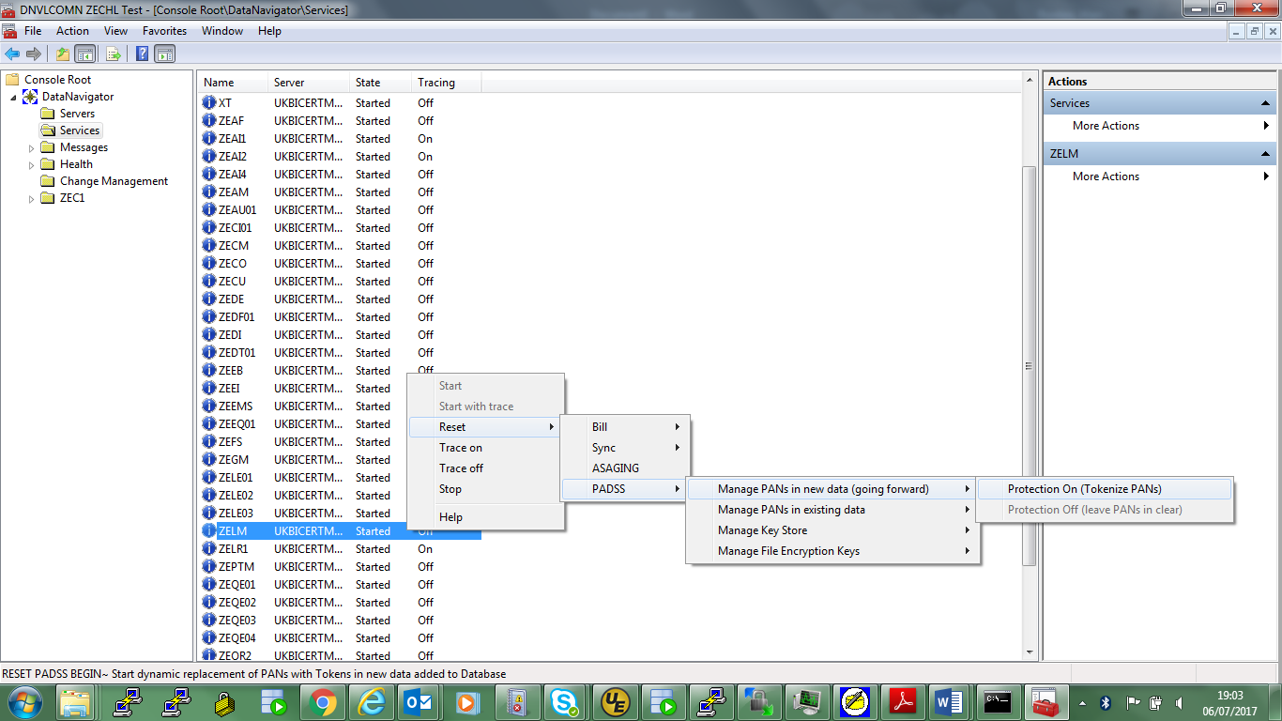

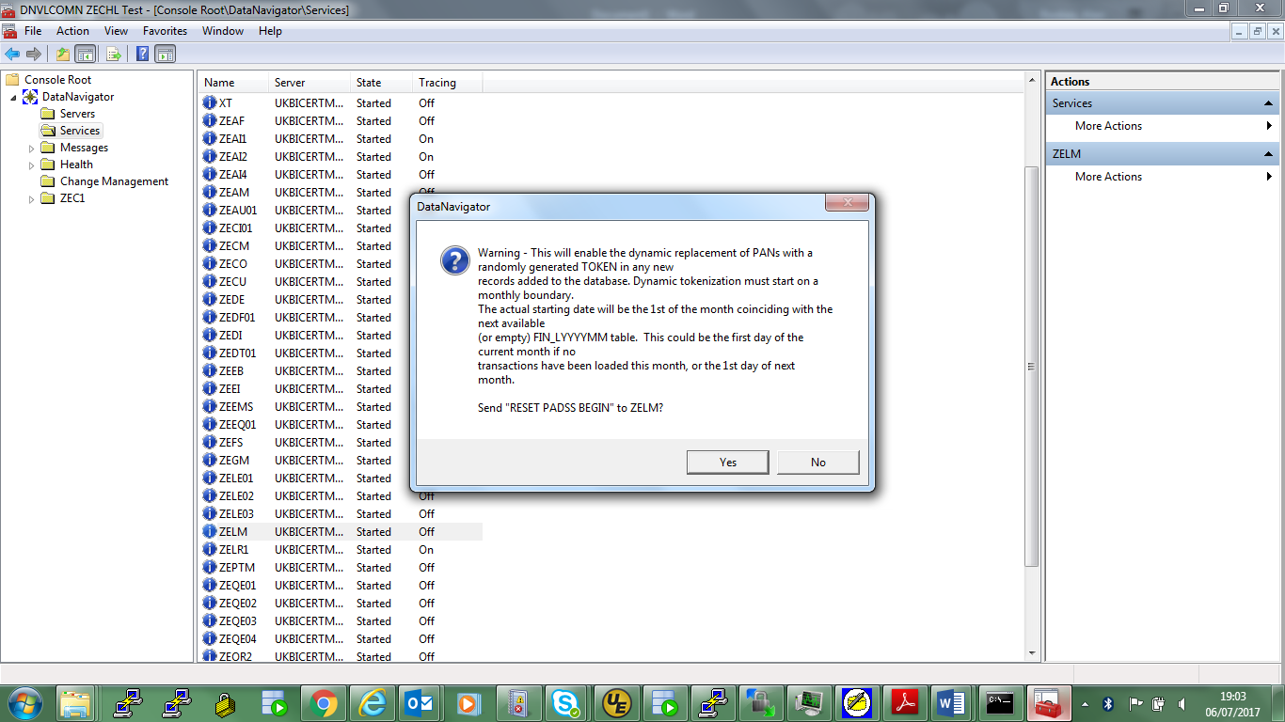

select * from &qualify..dn_symbols order by symbol_id, seq_no;

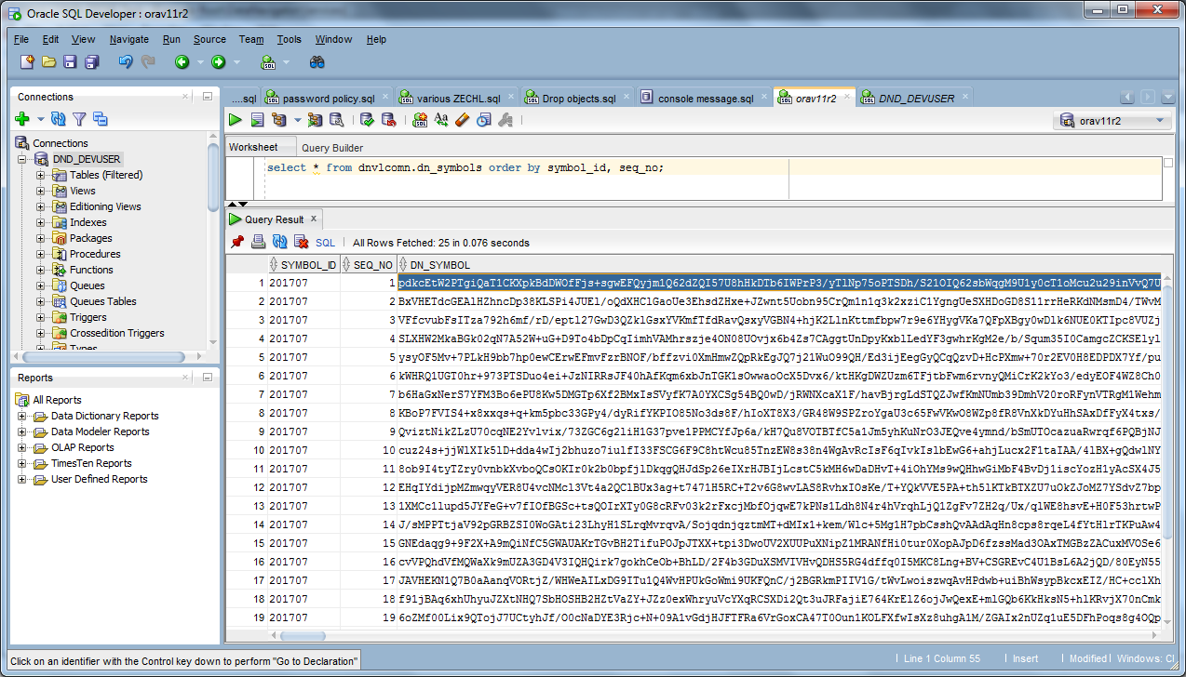

No transactions loaded in 201707 in this case so starts in the current month, otherwise the historic option would need to be used in the LM console commands to go backwards in time after loading. Refer to PA-DSS Implementation Guide for DataNavigator doc.

That doc does not cover this but all DN tasks must be restarted after the DN_SYMBOLS table is populated as all tasks (even those that do nothing with PANs) read this into memory on startup. LE, QE, RE, EI etc tasks will all need these symbols when handling PAN data.

